**CHAPTER 1**

**INTRODUCTION**

**1.1** **What is Codechef?**

CodeChef is a not-for-profit educational initiative by [Directi](http://www.directi.com/), an Indian software company. It is a global programming community that fosters learning and friendly competition, built on top of the world’s largest competitive programming platform.

CodeChef was created as a platform to help programmers make it big in the world of algorithms, computer programming and programming contests. Apart from this, the platform is open to the entire programming community to host their own contests. Major institutions and organizations across the globe use our platform to host their contests.

**1.2** **What is CoderByte?**

Coderbyte is a web application built to help you practice programming and improve your coding skills. They offer a collection of code challenges and web development course that helps to prepare for an upcoming job interview or coding bootcamp.

The coding challenges range in difficulty and they can all be completed straight through our online application.

**1.3 What is Spoj?**

The SPOJ platform is centered around an online judge system, which serves for the automatic assessment of user-submitted programs. Some of its most important features include:

* support for more than 45 programming languages and compilers, including C, C++, Pascal, JAVA, C#, Perl, Python, Ruby etc.
* a rapidly growing problem-set of about 13000 tasks available for practice 24hours/day (in English, Polish, Vietnamese, Portuguese and other languages).
* a flexible testing system, supporting dynamic interaction with submitted programs and highly customisable output of assessment results.
* intuitive browser-based content management which allows users to set up their own contests within a matter of minutes, and to make use of tasks already available in the system.

**1.6 Existing development**

Presently, we are able to search about details of each separately, i.e , we need to browse each of the websites separately for any information regarding the users or the contests. We do not have a single portal to handle them all together and manage their data at one place.

**1.5 Objective and scope of work**

In this project,we aim to reduce the problem of searching about any piece of information regarding either the users or the contests in the above three sites. We provide coders with a tool that helps them to get the details easily and interactively at one place. The results are from the combined results of the three sites ,hence eliminating the hassle of going through each one of them everytime.

**CHAPTER 2**

**PROJECT REQUIREMENTS**

**2.1 SOFTWARE REQUIREMENTS**

* Operating System :UBUNTU 16.04
* Programming language : Python,Html,CSS,
* Database : MySQL
* Web Framework –Django

**2.2 HARDWARE REQUIREMENTS**

* Processor inteli3 2.4GHz, 64bitprocessor
* Ram 4GBRAM
* Hard Disk 100GB

**CHAPTER 3**

**PROBLEM STATEMENT**

To create a Database management system for online coding sites where :

* Users can search about any contest held by the sites
* Users can check who has given what type of answer(status of the answer ) and can view their profile in the corresponding site.
* Users can view the rankings of candidates
* Admin can add new users to the table
* Other users can only use the system for viewing

**CHAPTER 4**

**SYSTEM DESIGN**

**4.1 SCHEMA MODEL**

**ADMIN**

**PASSWORD**

**USER-NAME**

USER – NAME

**DETAILS**

**SITE-ID**

**USER-NAME**

**NAME**

**RANK**

**INSTITUTE**

**COUNTRY**

**QUESTIONS**

**SITE-ID**

**CONTEST-CODE**

**QUESTION-CODE**

**RESULT**

**ID**

**SITE-ID**

**USER-NAME**

**CONTEST-CODE**

**QUESTION-CODE**

**RESULT**

**LANGUAGE**

**SITES**

**SITE-ID**

**SITE**

**USERS**

**SITE-ID**

**USER-NAME**

**4.2 E-R DIAGRAM**

**4.2 E-R MODEL**

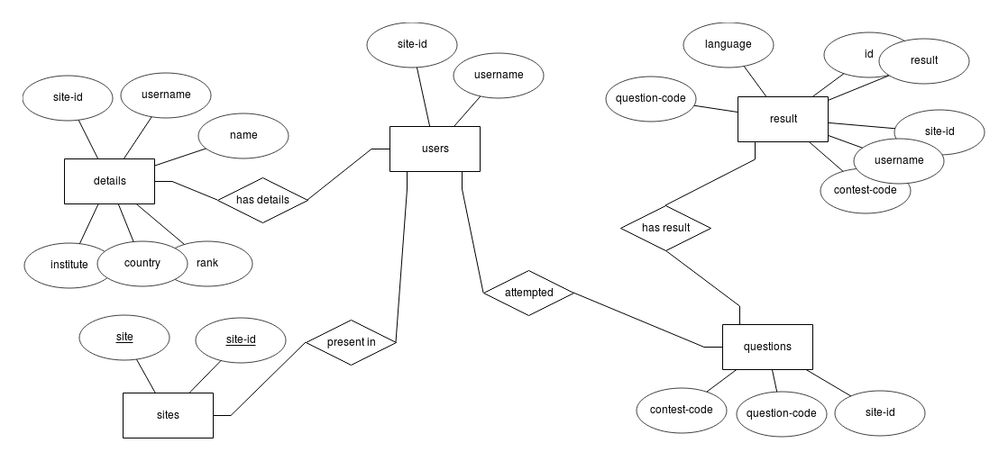

**4.3 LIST OF TABLES**

Admin table

+----------+-------------+------+-----+---------+-------+

| Field | Type | Null | Key | Default | Extra |

+----------+-------------+------+-----+---------+-------+

| username | varchar(40) | NO | PRI | NULL | |

| password | varchar(40) | NO | | NULL | |

+----------+-------------+------+-----+---------+-------+

Table 4.3.1

Details table

+-----------+--------------+------+-----+---------+-------+

| Field | Type | Null | Key | Default | Extra |

+-----------+--------------+------+-----+---------+-------+

| site_id | int(11) | NO | PRI | NULL | |

| username | varchar(100) | NO | PRI | NULL | |

| name | varchar(100) | NO | | NULL | |

| rank | int(11) | NO | PRI | NULL | |

| institute | varchar(100) | NO | | NULL | |

| country | varchar(50) | NO | | NULL | |

+-----------+--------------+------+-----+---------+-------+

Table 4.3.2

Result table

+---------------+--------------+------+-----+---------+----------------+

| Field | Type | Null | Key | Default | Extra |

+---------------+--------------+------+-----+---------+----------------+

| id | bigint(20) | NO | PRI | NULL | auto_increment |

| site_id | int(11) | NO | MUL | NULL | |

| username | varchar(100) | NO | | NULL | |

| contest_code | varchar(100) | NO | | NULL | |

| question_code | varchar(100) | NO | | NULL | |

| result | varchar(50) | NO | | NULL | |

| language | varchar(50) | NO | | NULL | |

+---------------+--------------+------+-----+---------+----------------+

Table 4.3.3

Questions table

+---------------+--------------+------+-----+---------+-------+

| Field | Type | Null | Key | Default | Extra |

+---------------+--------------+------+-----+---------+-------+

| site_id | int(11) | NO | PRI | NULL | |

| contest_code | varchar(100) | NO | PRI | NULL | |

| question_code | varchar(100) | NO | PRI | NULL | |

+---------------+--------------+------+-----+---------+-------+

Table 4.3.4

Sites table

+---------+-------------+------+-----+---------+----------------+

| Field | Type | Null | Key | Default | Extra |

+---------+-------------+------+-----+---------+----------------+

| site_id | int(11) | NO | PRI | NULL | auto_increment |

| site | varchar(50) | NO | PRI | NULL | |

+---------+-------------+------+-----+---------+----------------+

Table 4.3.5

Users table

+----------+--------------+------+-----+---------+-------+

| Field | Type | Null | Key | Default | Extra |

+----------+--------------+------+-----+---------+-------+

| site_id | int(11) | NO | PRI | NULL | |

| username | varchar(100) | NO | PRI | NULL | |

+----------+--------------+------+-----+---------+-------+

Table 4.3.6

**CHAPTER 5**

**IMPLEMENTATION**

Our project has been implemented using MySQL database and Django.

**5.1 MySQL**

MySQL is an open source relational database management system (RDBMS) based on structured query language.

* Although it can be used in a wide range of applications, MySQL is most often associated with web-based applications and online publishing.
* MySQL works on many operating systems and with many languages including PHP, PERL, C, C++, JAVA, etc.
* MySQL is customizable. The open-source GPL license allows programmers to modify the MySQL software to fit their own specific environments.
* MySQL is pretty easy to master in comparison with other database software like Oracle Database, or Microsoft SQL Server.

**5.2 Django**

[Django](https://www.djangoproject.com/) is a free and open source web application framework written in Python. A framework is nothing more than a collection of modules that make development easier. They are grouped together, and allow you to create applications or websites from an existing source, instead of from scratch..

* Django’s template language is designed to feel comfortable and easy-to-learn to those used to working with HTML, like designers and front-end developers.
* Django offers a big collection of modules which you can use in our projects
* Django can be (and has been) used to build almost any type of website — from content management systems and wikis, through to social networks and news sites.
* Django helps developers avoid many common security mistakes by providing a framework that has been engineered to "do the right things" to protect the website automatically.

**CHAPTER 6**

**RESULTS**

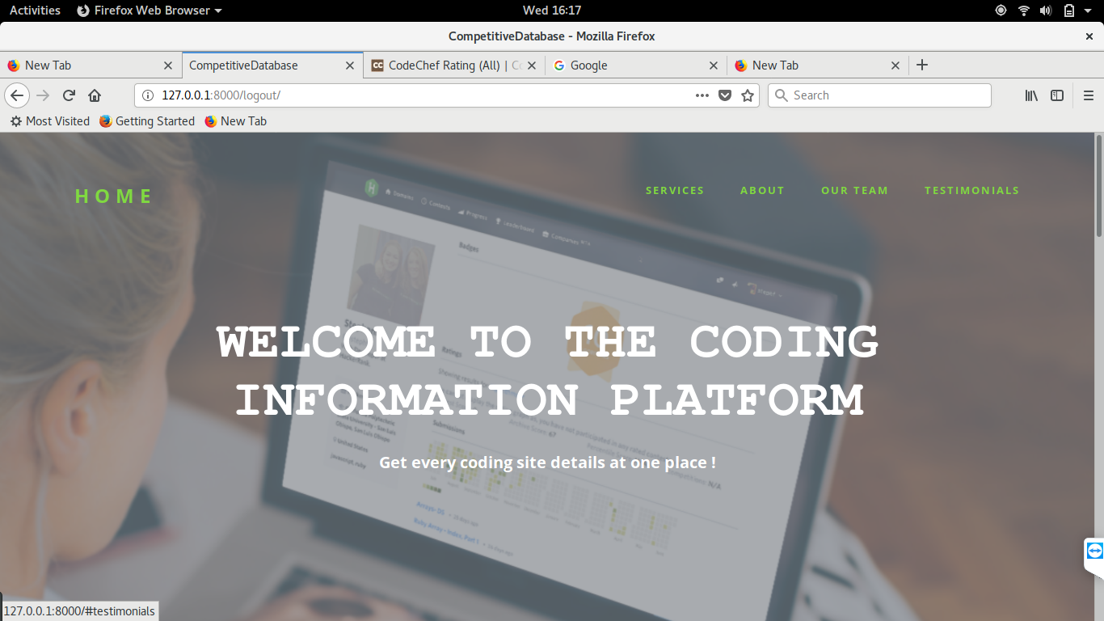

**6.1 HOME PAGE**

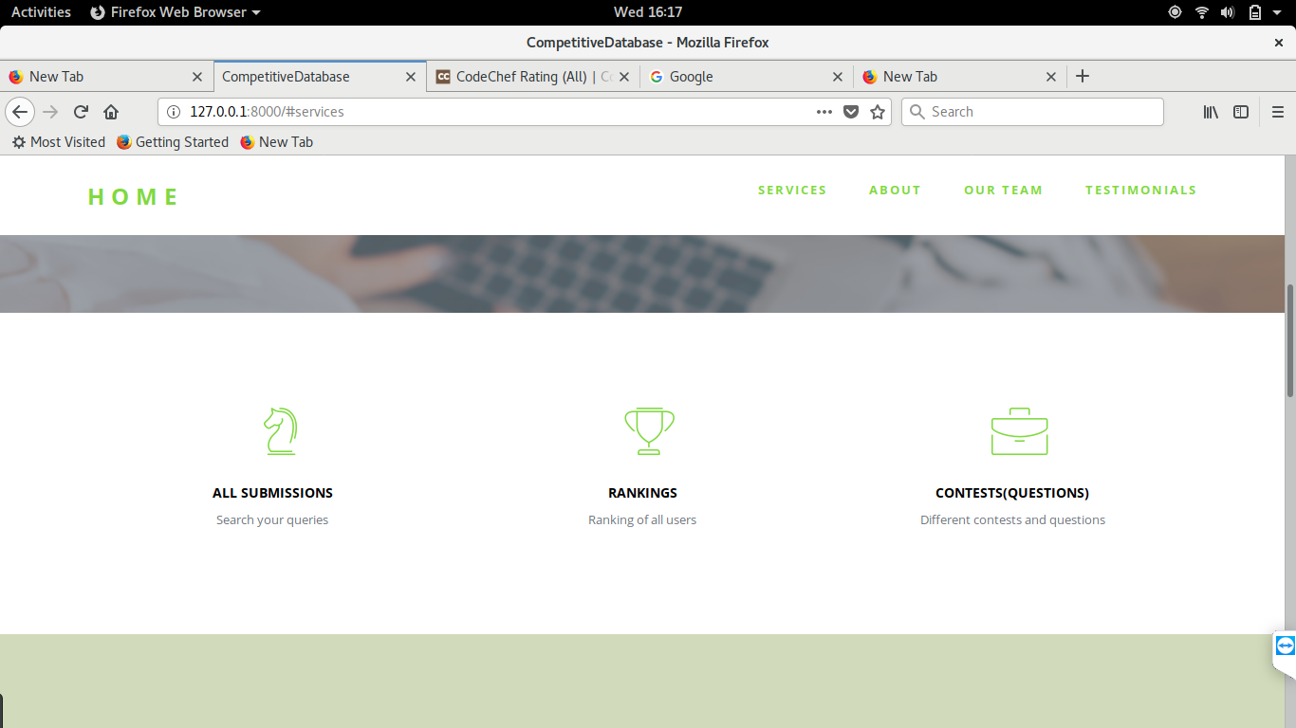

**6.2 OUR SERVICES**

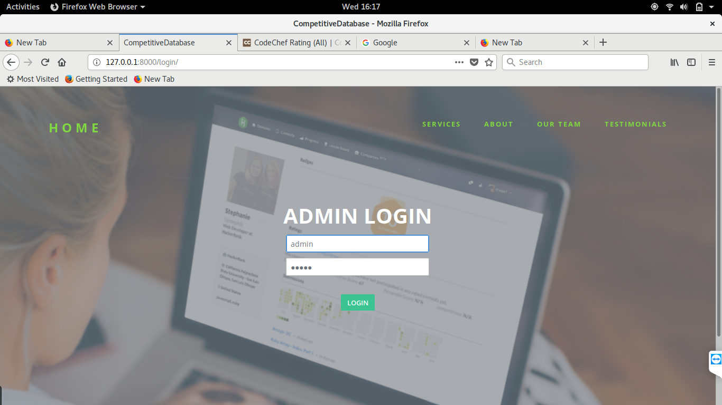

**6.3 LOGIN PAGE**

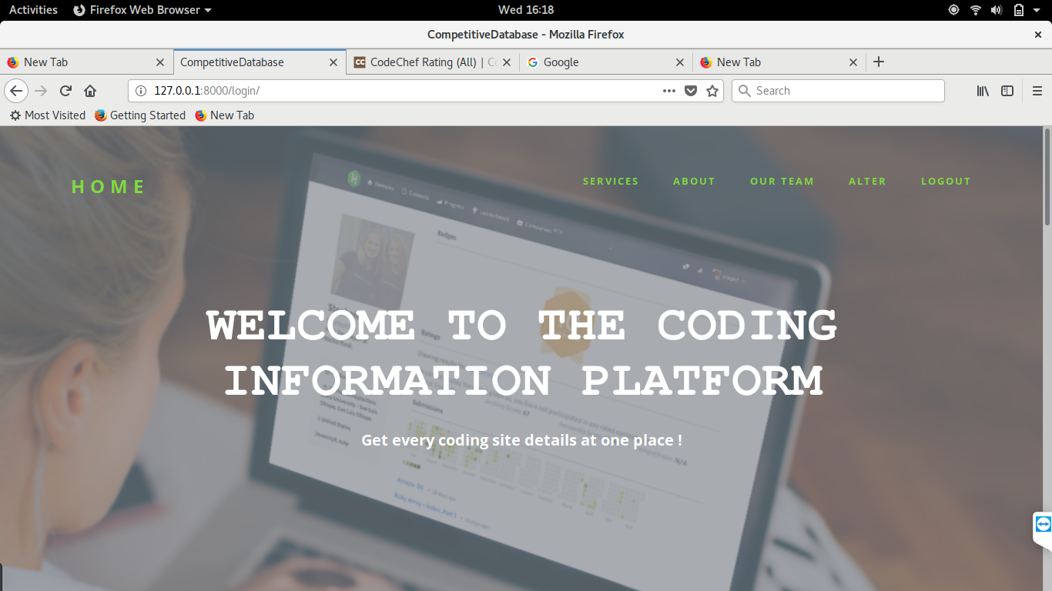

**6.4 OPTIONS AFTER LOGIN**

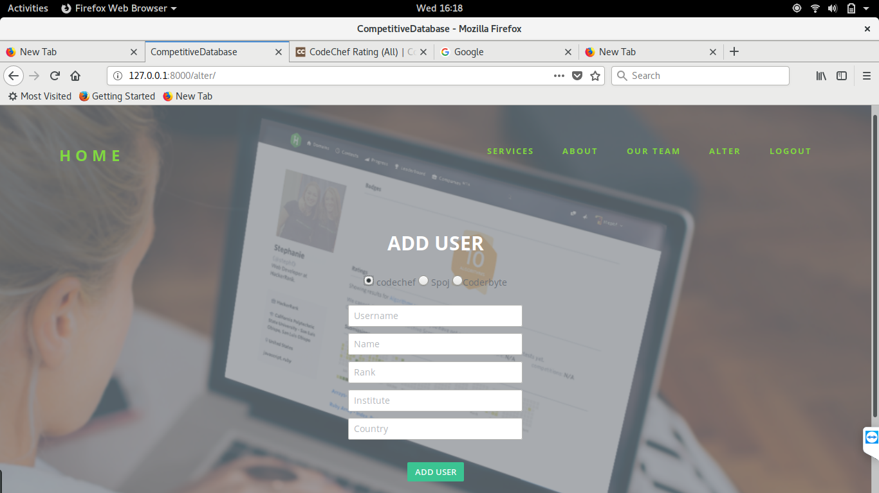

**6.5 ADDING A NEW USER**

**CONCLUSION**

Computer programming jobs may be declining , but coding is becoming the most in-demand skill across industries. Interestingly enough, programming language courses are being added into the curriculum of schools and universities across the national.

Through this project , we are now able to encourage the coding process by making it very simple for coders to retrieve information from their favourite coding web sites.

Users can now check the coder details, their rankings in respective websites and all the contest and question details by utilizing our project.

**REFERENCES**

**BOOKS**

1. Database systems Models, Languages,Design and Application Programming, Ramez Elmasri and Shamkant B. Navathe.
2. Database management systems, Ramakrishnan, and Gehrke.

**WEBSITES**

1. <https://developer.mozilla.org/en-US/docs/Learn/Server-side/Django>
2. <http://web.stanford.edu/~zlotnick/TextAsData/Web_Scraping_with_Beautiful_Soup.html>
3. <https://www.w3schools.com/>